A Kingswood Fish… 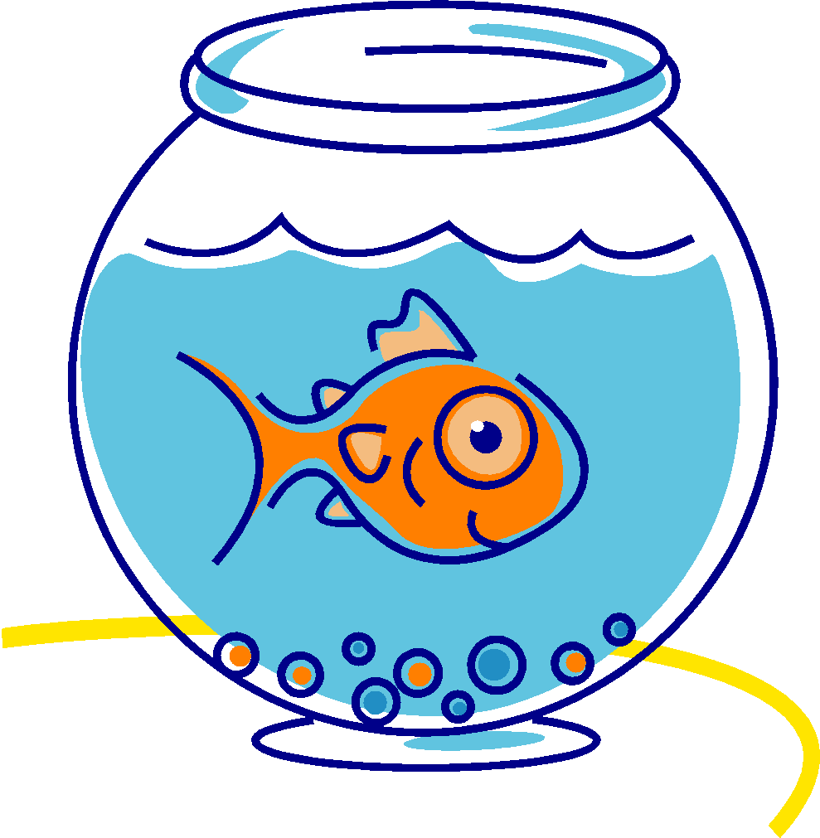

|  |  |
| --- | --- |
| Stays Safe |  |
| Works Hard |  |
| Is respectful and kind |  |
| Manages Actions |  |